Roy and Profile Picture | Basics of Input/Output & Basic Programming Practice Problems
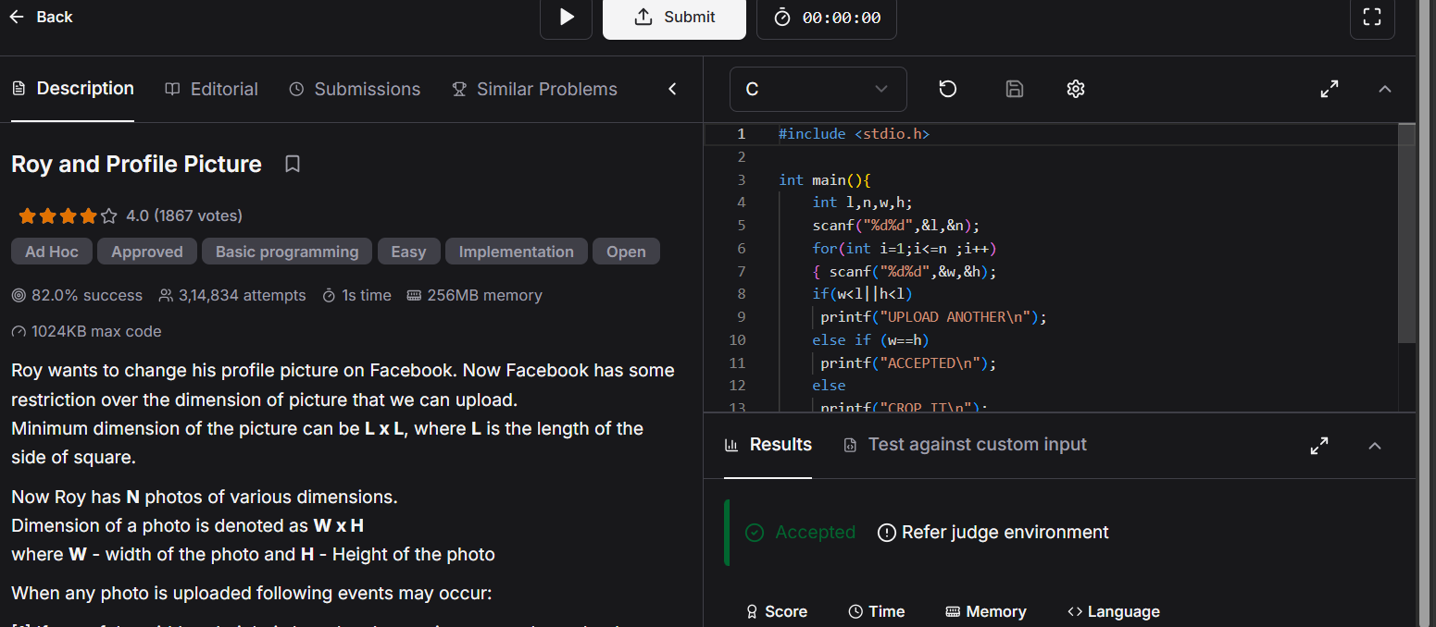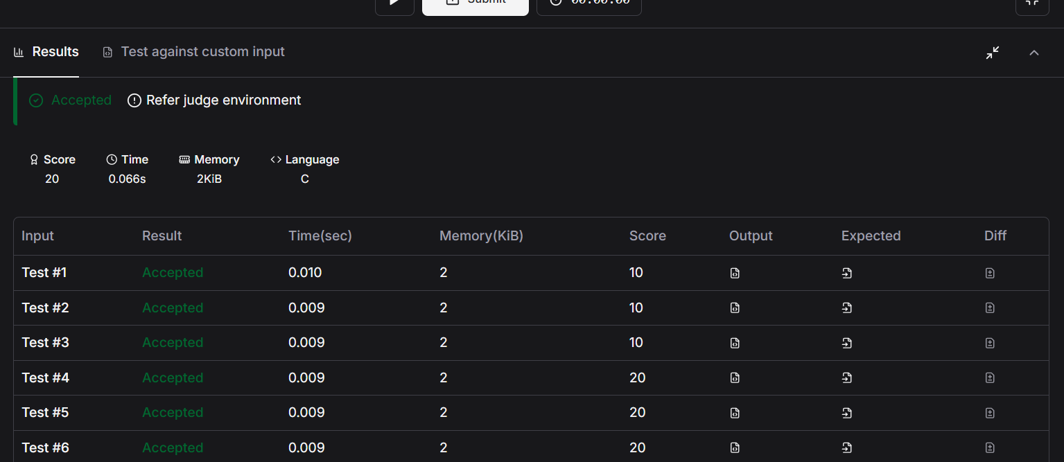#include <stdio.h>

int main(){
int l,n,w,h;
scanf("%d%d",&l,&n);
for(int i=1;i<=n ;i++)
{ scanf("%d%d",&w,&h);
if(w<l||h<l)
printf("UPLOAD ANOTHER\n");
else if (w==h)
printf("ACCEPTED\n");
else
printf("CROP IT\n");
}
return 0;
}

